Helix Engine Development Docs

Introduction:

Helix engine is a modular 3D engine system designed to be used and imported in python to help with developing 3D games in python.

The Engine will be developed in a low-level language like rust and can be imported to python, it will have multiple modules, one for 3D rendering the others for a Physics engine, they will be developed separate from each other.

Library overview:

The HelixRender (3D renderer module) will be developed using GPU compute shaders for custom rasterization to maintain full control over every pixel. The renderer can be used separate from the other modules so the developer can use it for simple scene rendering.

The HelixDynamics (Physics module) will have multiple modules to allow the developer to only use the necessary components for their game.

Theoretical usage:

Each module of the engine can be imported in python or possibly in any other language should we chose to add support for.
e.g. in python:
from Helix.render import Scene, Camera, Cube, ModelRenderer

# Initialize a new scene with a default camera
scene1 = Scene(background_color=(255, 255, 255))
scene1.cameras[0].set_fov(90)
scene1.set_active_camera(0)

# Load and configure a 3D model
model = ModelRenderer(path='model.obj')
model.set_scale(10, 10, 10)
model.set_texture(path='texture.png')

# Add objects to the scene
scene1.add_object(model3D=model, x=10, y=0, z=5)
scene1.add_object(model3D=Cube(10, 10, 10), x=5, y=10, z=10)

# Apply a shader to the scene (optional)
scene1.show() # opens window
screen =scene1.render(shader_path="shaders/basic_lighting.glsl") # Updates window with render and returns an array

Development Stack overview:

Engine Core – Rust+glam – High-performance implementation of rendering and physics modules.
API – Python(PyO3) - Exposes the engine modules for scripting, scene management, and developer accessibility.
Shaders – GLSL – GPU compute shaders for rasterization, lighting, and advanced effects.

Helix Renderer structure:
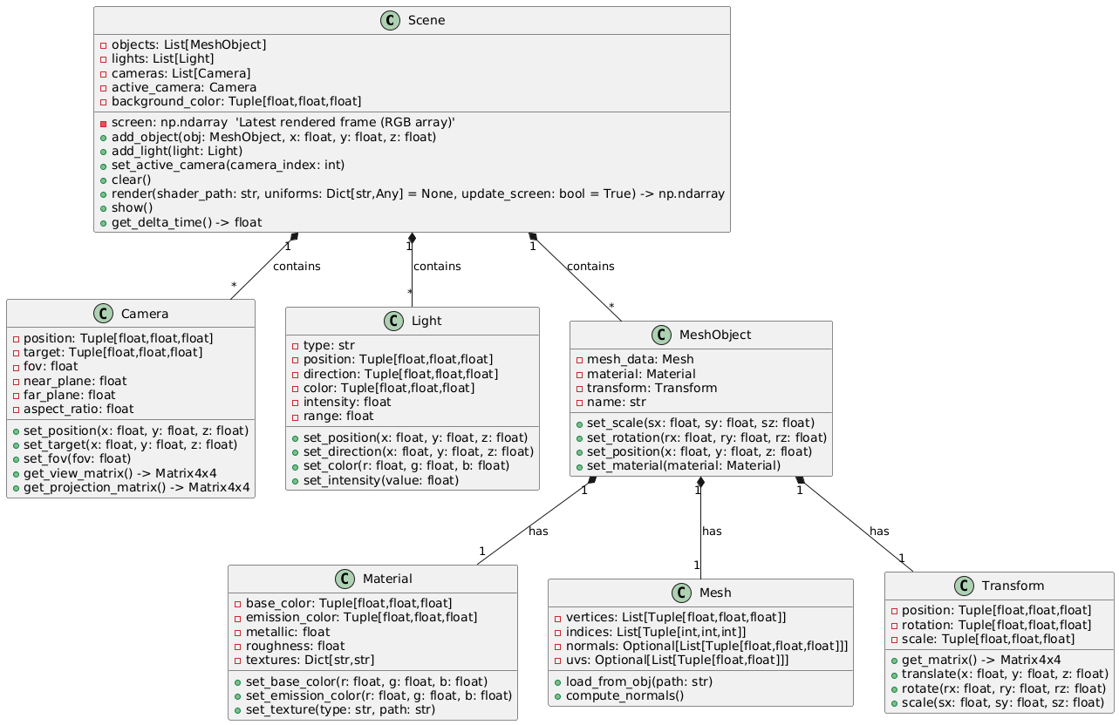

v0.1 Feature Scope for Helix-Renderer:
Goal: Have a working 3D scene that can render basic meshes to a window, with a screen buffer accessible in Python. Keep shaders simple GLSL files, one camera, one basic light (optional for v0.1), and focus on the render → screen → show workflow.

1. Scene Management
- Ability to create a Scene object.
- Add objects (MeshObject) to the scene.
- Add a camera (at least 1 default camera).
- Set active camera.
- Background color setting.

2. Rendering
- render(shader_path, uniforms=None, update_screen=True)
Should compute a frame and optionally update Scene.screen.
Returns RGB array of rendered frame.
- Support basic mesh objects (cube, sphere, or simple OBJ loader).
- Screen buffer (screen) attribute to store last rendered frame.

3. Display
- show() method to open a window and display Scene.screen.
- Ensure window updates properly after render.
- Event loop for closing window gracefully (basic).

4. Camera
Camera class with position, target, and FOV.
Projection/view matrix calculation (simplified).

5. Basic Utilities
clear() method to reset scene objects if needed.
get_delta_time() for basic frame timing (optional, but useful for animation).

Features to Exclude from v0.1 (for later versions)
shader support: read GLSL file and apply simple per-pixel output.
Complex materials (metallic, roughness, PBR).
Multiple light types, shadows, global illumination.
Advanced shader pipelines / compute shader optimizations.
Post-processing effects.
Scene serialization / saving/loading.
Python-Rust interop beyond the minimal API.

Helix Render File format:

HelixRender/
├── Cargo.toml # Rust package manifest
├── README.md
├── pyproject.toml # Optional: if using maturin for Python packaging
├── src/ # Rust source code
│ ├── lib.rs # Main Rust library entry (expose bindings)
│ ├── scene.rs # Scene struct & object management
│ ├── camera.rs # Camera struct
│ ├── mesh.rs # Cube, Sphere, MeshObject structs
│ ├── renderer.rs # render() and GPU interface
│ └── shader.rs # Shader loading and compilation
├── shaders/ # GLSL shader files
│ └── basic.glsl
├── examples/ # Example Python scripts using the Rust API
│ └── basic_scene.py
├── tests/ # Rust unit tests
│ ├── test_scene.rs
│ ├── test_camera.rs
│ └── test_renderer.rs
└── target/ # Rust build output (ignored in git)

Transform Component:

The Transform is the core mathematical component used to represent the position, orientation, and scale of a 3D model in world space. It produces a 4×4 transformation matrix, which is applied to every vertex of a mesh before rendering. This matrix contains the combined effects of translation, rotation, and scaling.
The transform matrix is structured as follows:
- The upper-left 3×3 block represents the model’s rotation.
- The rightmost 3×1 column represents the translation vector (x, y, z).
- The final row is always (0, 0, 0, 1) to preserve affine transformation properties.
A pure translation matrix looks like:
$$T=\left[\begin{matrix}1 & 0 & 0 & dx \\ 0 & 1 & 0 & dy \\ 0 & 0 & 1 & dz \\ 0 & 0 & 0 & 1\end{matrix}\right]$$

Rotation Using Quaternions
Representing 3D rotations using Euler angles (yaw, pitch, roll) can lead to gimbal lock. To avoid this, rotations are represented using unit quaternions, which provide smooth, continuous rotation without singularities.
A quaternion is written as:
$$q=a+bi+cj+dk$$
where:
- $a=cos⁡(θ/2)$
- $(b,c,d)=sin⁡(θ/2)⋅(u_{x},u_{y},u_{z})$
- $\vec{u}$ is the unit axis of rotation.
Thus:
$$q=cos⁡(θ/2)+u_{x}sin⁡(θ/2)i+u_{y}sin⁡(θ/2)j+u_{z}sin⁡(θ/2)k$$
Combining Rotations
Yaw, pitch, and roll are converted into individual quaternions:
$$q_{\text{total}}=q_{\text{roll}}⋅q_{\text{pitch}}⋅q_{\text{yaw}}$$
Quaternion multiplication is non-commutative, so the order matters.

Quaternion to Rotation Matrix
Once the final rotation quaternion $q=(a,b,c,d)$is computed, it is converted into a 3×3 rotation matrix using:
$$R=\left[\begin{matrix}2\left(a^{2}+b^{2}\right)-1 & 2(bc-ad) & 2(bd+ac) & 0 \\ 2(bc+ad) & 2\left(a²+c²\right)-1 & 2(cd-ab) & 0 \\ 2(bd-ac) & 2(cd+ab) & 2\left(a^{2}+d^{2}\right)-1 & 0 \\ 0 & 0 & 0 & 1\end{matrix}\right]$$
This matrix is a proper rotation matrix (orthonormal with determinant = 1), making it suitable for 3D rendering.

Scaling Matrix
Scaling is applied independently through a diagonal matrix:
$$S=\left[\begin{matrix}Sx & 0 & 0 & 0 \\ 0 & Sy & 0 & 0 \\ 0 & 0 & Sz & 0 \\ 0 & 0 & 0 & 1\end{matrix}\right]$$
Final Transformation Matrix
The final 4×4 transform is computed in this order:
$$M=T⋅R⋅S$$
This means:
- The model is scaled.
- Then rotated.
- Then moved into world space via translation.
This ordering matches common graphics conventions (OpenGL, most engines).

Sources
1. Martin John Baker — “Using 4×4 matrix to represent rotation and translation”
https://www.euclideanspace.com/maths/geometry/affine/matrix4x4/index.htm
2. David W. Lyons — “Quaternions”
https://math.libretexts.org/Bookshelves/Abstract_and_Geometric_Algebra/Introduction_to_Groups_and_Geometries_(Lyons)/01:_Preliminaries/1.02:_Quaternions
3. John D. Cook — “Converting between quaternions and rotation matrices”
https://www.johndcook.com/blog/2025/05/07/quaternions-and-rotation-matrices/

MeshObject:

A MeshObject represents a single 3D model instance stored within the rendering engine. It contains the mesh identifier, a name assigned by the user, and its associated Transform, which describes the object’s position, rotation, and scale within the scene.

The MeshObject does not hold the vertex data directly; instead, it references a mesh entry stored in a central mesh registry. This design avoids duplication of geometry and allows many MeshObjects to share the same underlying mesh.

Each MeshObject exposes methods to modify its Transform. The Scene system uses this structure to build world-space matrices for rendering, ensuring each object’s position, rotation, and scale are applied correctly in 3D space.

Scene:

The Scene acts as a container and manager for all MeshObjects. It maintains arrays for objects, mesh references, and generation counters.

The Scene provides high-level operations such as adding objects, retrieving them by name, applying transformations through Python calls, and computing final transformation matrices for rendering.

By separating the Scene from the MeshObject, the architecture cleanly distinguishes “what exists in the world” (Scene) from “what each object stores” (MeshObject). This separation allows future features such as multiple scenes, scene graphs, object culling, or mesh instancing.
Python Handle System:

Because Python cannot safely hold direct references to Rust objects, the engine exposes object access through a PyObjectHandle.

A handle contains only two values: an index into the Scene’s object list and a generation number representing the version of the object at that slot. This allows Python to pass lightweight references without owning the Rust data, while still ensuring safety.

When Python calls a method such as translate_object(handle, vector), the Scene receives the handle, validates it, and, if valid, applies the operation to the corresponding MeshObject. This approach avoids Rust lifetime issues and gives Python an efficient, user-friendly API for manipulating scene content.

Generational indexing:

The engine uses generational indexing to prevent invalid or stale handles from being used after an object is removed or replaced.

Each slot in the Scene’s object array has an associated generation counter. When a MeshObject is created, its generation is recorded inside the handle returned to Python.

If an object is later removed or replaced, the generation counter is incremented. Any old handles will now contain a mismatched generation number and are automatically rejected. This guarantees that Python cannot accidentally reference freed memory or a different object that reused the same slot.

Generational indexing is a lightweight but robust technique widely used in modern game engines to maintain safe, stable references between scripting languages and native code.

